Home › General Ledger › Finance Configuration › Global Finance Settings
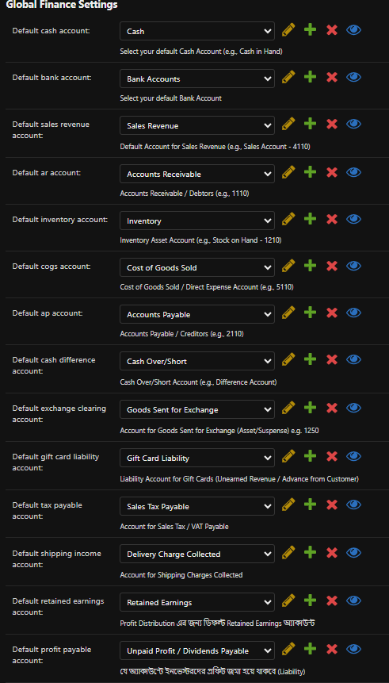

Home › General Ledger › Chart of Accounts

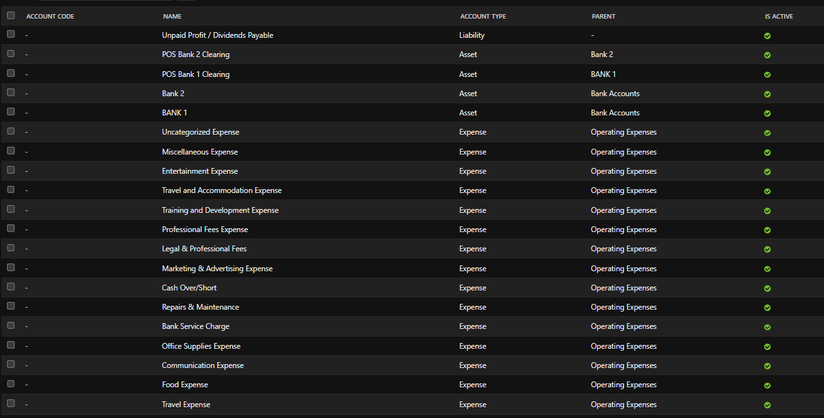

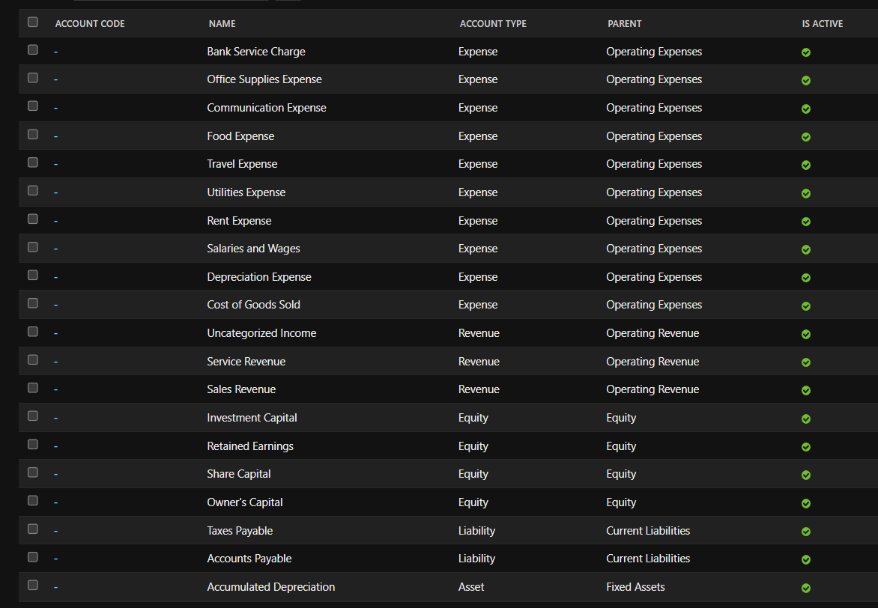

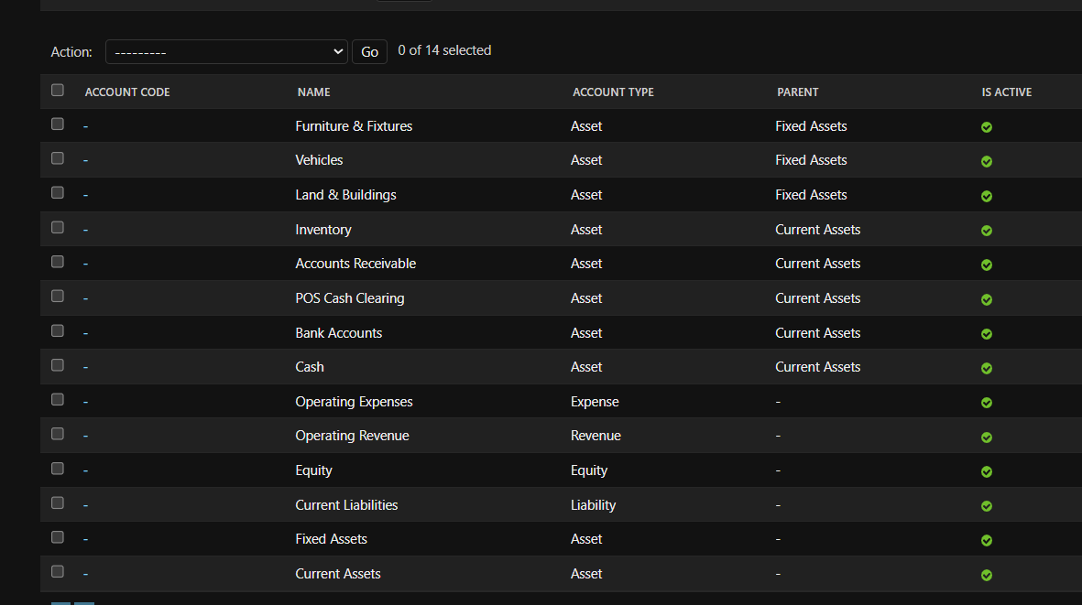
Home › Cash › Cash Registers
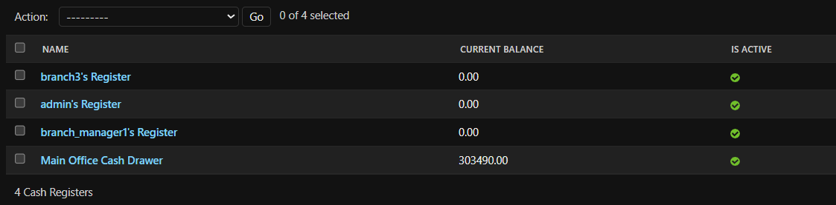

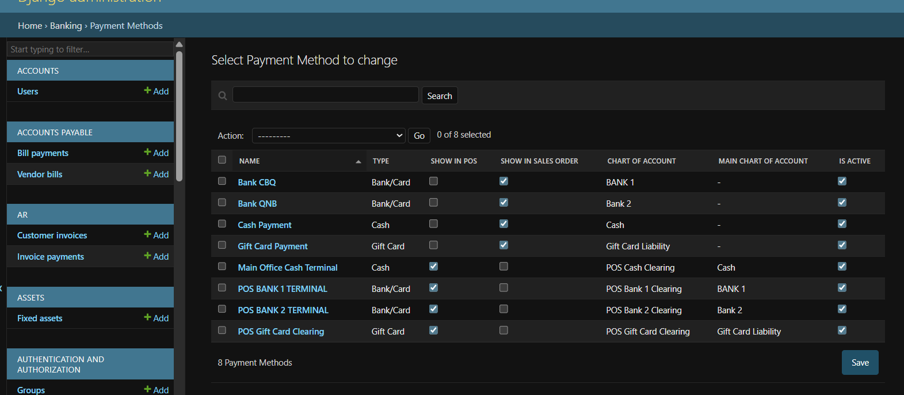
Home › Banking › Payment Methods

Home › Banking › Bank accounts
